A Process to Build and Lead High Performing Teams
Interactive Module
A Process to Build and Lead High Performing Teams Interactive Module provides business leaders with the knowledge and tools to build and lead high performing teams. The module contains a step-by-step process for building a team and a collection of tools and resources for building, leading, and improving teams. Self-paced 20 minute module available on all devices.
Click on the link below to access the resource:
http://clc.business.wfu.edu/module/HighPerformingTeamsSLDS7717/story_flash.html

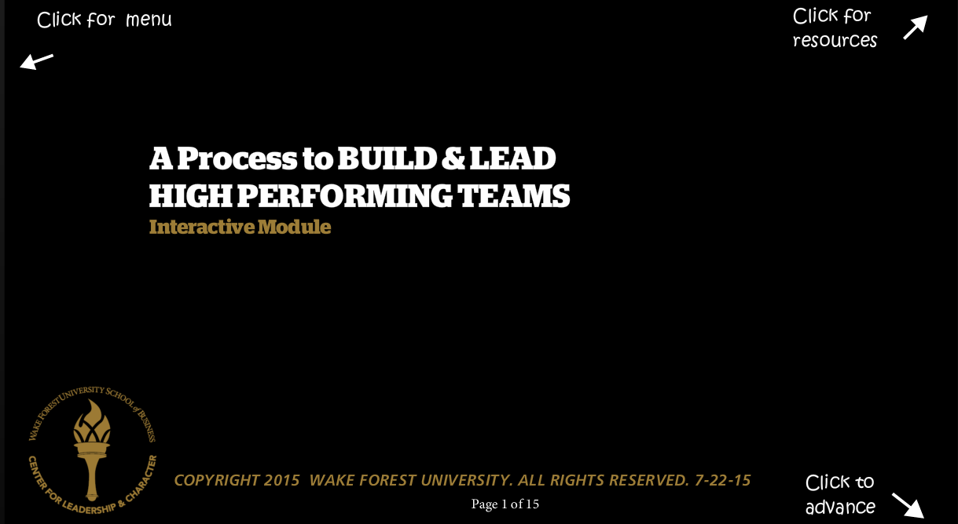

Audio Transcript:
Page 1-
Welcome to “A Process to Build and Lead High Performing Teams.” This interactive module should take about 20 minutes to complete. The goal is to provide business leaders with the knowledge and tools to build and lead high performing teams. Please click on the next button to get started.
Page 2-
Leading teams is important for business leaders and it's important for the mission of the school of business to develop ethical passionate business leaders who achieve results with integrity. Please click on the infographics for “Ten Surprising Facts about High Performing Teams” and “Seven Differences Between High Performing and Low Performing Teams” to give you an overview, and then click on the next button to continue.

Page 3-
When teams form, they start a life cycle. Before a team can reach effective performance, it needs to work out how the members contribute to the goals and how the team operates to reach those goals. In the following pages, you'll find a step-by-step process for building a team and a collection of tools and resources for building, leading, and improving teams. Use your academic knowledge and professional experience to guide your use of these resources. Click on the link for "Tuckman's Team Development Model" as a sample team development framework.

Page 4-
Step one in the process begins when you establish relationships on the team. This helps to shape a climate of trust and collaboration as the project starts, so please take time to build this element of your team at the start.

Page 5-
In step two, you forge the team’s purpose, values, and vision. During the first formal gathering, create the teams operating plan which serves as the foundation for its culture. Work on a white board or a flip chart to identify core values and purpose and to define the end state for the project.

Page 6-
In step three, you determine how the team operates and start building the team charter. Click on the buttons to work through the various areas of interest in building your team charter. You'll collect all of your ideas and finalize it in the next step.

Page 7-
In step four, you codify the team’s operation and processes into a team charter. This is where you capture in one document all of your agreements and get your team members to review it to ensure consensus. Set a time on the team calendar to review the charter periodically to make sure you stay aligned and then adjust it as needed going forward with your project.

Page 8-
To continue improving your team and delivering results, you'll want to focus on resolving conflict as it arises. Please click on the answer buttons for ideas and answers to frequently asked questions so that your team can continue to stay at a state of high performance by solving problems and conflicts effectively.

Page 9-
To continue to deliver results and improve your team, make sure you use a sound decision making model. Click on the links for supplemental resources that will help you to work through challenges and make ethical decisions as they arise.

Page 10-
Delivering results and improving your team also means leading effective meetings. Effective meetings lead to greater productivity and include preparation before the meeting, leadership during the meeting, and a follow up after. Click on the buttons for more suggestions about best practices before, during, and after the meeting.

Page 11-
Communicating effectively is so important on a high performing team. This means giving and receiving feedback effectively. Please click on the buttons and the links for more information to help you plan your feedback sessions and take action on the feedback you receive. This ensures an open flow of communication on your team to bring it into high performance.

Page 12-
Delivering consistent results with integrity takes attention. At any time during your team process you can use this check list in order to have a reality check and keep your standards high so that your team can continue to deliverer its best.

Page 13-
Another way to continue to improve your team and to deliver results is to ensure team learning. This happens through conducting after action reviews after major events or deliverables with your team and also conducting frequent team check-ins. Use what you've learned to improve your processes and relationships.

Page 14-
As you bring your team experiences to a close, continue to invest in team relationships. This means celebrating wins and recognizing each other's contributions. Remember, you are building a professional network you will take with you after the project ends.

Page 15-
As we bring this module to a close, please review the best practices for leading and building a high performing team. Thank you for your time and attention and please click on the links for additional resources.

