Elon Musk and Twitter Slashing Workforce
Background
During the summer of 2022, Elon Musk acquired Twitter including an elite workforce of 7,500 employees. Musk’s intention with buying Twitter was to “free the bird.” At a price tag of $44bn, Twitter boasted assets including infrastructure and brand. While employees generally appear on a balance sheet as costs, in a technology company like Twitter, they play a more important role as assets for the company.
In today’s world, people are needed to innovate, improve, and protect the company’s core business and interests. The value of people in an organization, especially a technology company, can be a powerful differentiator and can be pivotal to a company’s success. Human assets need to be valued within a healthy cultural framework for the company in order for the company to sustain long term success. When this is lacking, the company integrity and management may come into question.
In mid-November, 2022, Elon Musk reduced the Twitter workforce by almost half via email without warning. He claimed reducing costs as a reason to eliminate 1700 workers. To deter pushback, he indicated he would also terminate any employees who would complain or who not agree to the hard-core 80 hour-long work weeks and stressful conditions. As a result, an additional 15% of his workforce quit. With human assets gutted from Twitter, the damage to the company could be impossible to rebuild. The immediate devaluing of the company is a reality Musk will have to face.
Musk Tries to Recover
Due to the exodus of employees from his company, Musk has quickly reversed tactics and is trying to hire back many of the employees he terminated. However, sending an email to the Twitter employees using phrasing like “anyone who actually writes software” did not buy him goodwill. His lack of personal knowledge about the technology structure also reduces his credibility in the eyes of the employees, stakeholders, and the public shown by his bringing in engineers from Tesla and SpaceX. Pundits are predicting Twitter won’t be able to be saved in a way that ensures future success.
With the company brainpower and innovators gone, Twitter is left with is broken infrastructure, damaged culture, and precarious brand. It’s questionable whether the company will even be able to maintain its basic service let alone innovate and improve. Advertisers are concerned about Twitter’s screening criteria and how the personnel are being treated.
The way forward through the rising incidents of bugs and glitches is unclear. The quality of service is in question and the prediction is customers will and advertisers will fade away. Worse, the stakeholders could use Twitter as a crowd-swelled platform for hateful tweets against the company.

Musk Has Supporters
Die-hard supporters say it is Elon Musk we’re talking about and a smart person “would never bet against this guy.” A solid employee base has stayed loyal to Musk with Musk praising “people who really see the vision and the goal,” though that may be a very small group. Other experts are predicting that young coders will flock to the empty spots in the company and bring new life and innovation into the ranks. Meanwhile, other cutting-edge technology companies are gathering up the exodus of brain power from Twitter to advance their own futures.
Secondary Effects in Tesla and the Way Ahead
As a result of the nearly year-long actions at Twitter, stock has dropped by 50% in Elon Musk’s Tesla company during 2022. For many, the actions at Twitter signal a warning across Musk’s enterprises. News headlines include pessimistic predictions such as: “Twitter Death Watch Captivates Millions.”
As the wealthiest man in the world, Musk enjoys a hard-core fan base including investors and financial experts. Some see the turmoil at Twitter as a moment in time and believe it signals a new opportunity for growth and industry dominance.
(This story has been and will continue to be updated as new information is available.)
Discussion Questions:
- What are the ethical implications business leaders need to consider when potentially planning a reduction in the workforce?

- Discuss the best ways to maintain trust with employees who survive the reduction in force.

- What is the most effective and ethical way to notify employees that they are being laid off?

- How do you conduct a reduction in the workforce while preserving the organization’s strong culture?

- How do you conduct a reduction in the workforce and still maintain trust with your key external stakeholders?

- In your opinion, is it ethical to ask employees to work 80-hour weeks with reduced resources? Why or why not?

- Based on the facts presented, assess Twitter’s current culture under Musk’s leadership. Be sure to identify values and underlying assumptions within leadership and within the workforce.

- Are drastic business decisions regarding personnel ethical, especially when those decisions devalue people with proven records?

Appendix A: Too Little Too Late as Musk Uses His Platform to Apologize
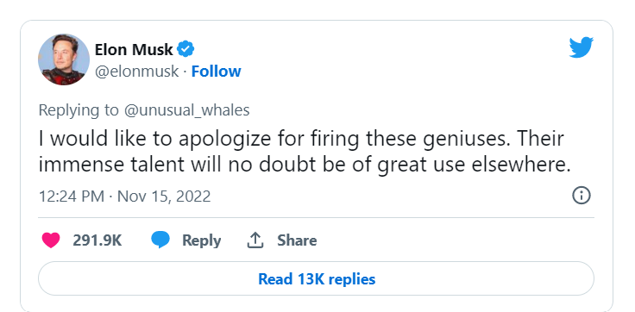

Appendix B: Full Email Musk Sent to Twitter Employees
Going forward, to build a breakthrough Twitter 2.0 and succeed in an increasingly competitive world, we will need to be extremely hardcore. This will mean working long hours at high intensity. Only exceptional performance will constitute a passing grade.
Twitter will also be much more engineering-driven. Design and product management will still be very important and report to me, but those writing great code will constitute the majority of our team and have the greatest sway.
At its heart, Twitter is a software and servers company, so l think this makes sense.
If you are sure that you want to be part of the new Twitter, please click yes on the link below:
Anyone who has not done so by 5pm ET tomorrow (Thursday) will receive three months of severance.
Whatever decision you make, thank you for your efforts to make Twitter successful.
Source: https://www.cnbc.com/2022/11/16/elon-musk-demands-twitter-staff-commit-to-long-hours-or-leave.html

